Operating Systems
MID-1 question bank
Unit-I
- What is an Operating System? Briefly discuss its functions?
- Explain the Open-Source operating systems?
- Discuss the types of System Calls and structure of a system call with an example
- Describe the Operating System Debugging?
- Explain about operating system services?
- Discuss the operating system structure?
- What are the different types of the Computing environments?
- Discuss the advantages and disadvantages of open-source operating systems?
- Discuss the role of the System Boot?
- Discuss the advantages and disadvantages of open-source operating systems?
Unit-II
1. What is a process? Draw the Process state diagram and explain its states.
2. Discuss the different approaches for Inter-Process Communication?
3. Describe the SJF scheduling algorithm with an example?
4. Explain the Readers and Writers problem?
5. Differentiate Pre-emptive and non pre-emptive scheduling algorithms?
6. What is a process, and how does process scheduling help in efficient CPU utilization?
7. Write the important characteristics of Round Robin Scheduling algorithm. And demonstrate its
Performance for the following workload in a system with time quantum = 2 units.
Consider the set of 5 processes whose arrival time and burst time are given below
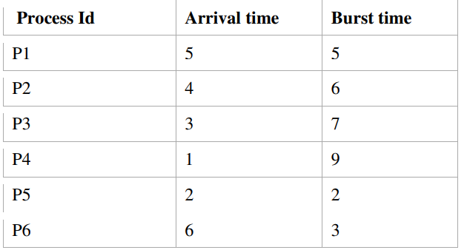
Draw a Gantt chart illustrating the execution of these jobs and also Calculate the average waiting and
average turnaround times.
8. Describe the FCFS scheduling algorithm with an example?
9. What is starvation? Describe the Priority scheduling algorithm with an example?
10. Define thread. Explain the main multithreading models? What are the advantages and disadvantages of each?
MID-2 question bank
UNIT-III
- What is Synchronization? What are the Classic problems of Synchronization.
- What is a deadlock? what are the characteristics of deadlock.
- What is meant by Starvation in Dining philosopher problem? Suggest a solution to solve this problem using Semaphores.
- What is the role of hardware in OS process synchronization? Explain how mutex locks are used.
- What is synchronization. Present the solution to critical section problem using locks.
- In detail explain Safety Algorithm and Resource-Request Algorithm for Process to arrive at safe state.
- What is a deadlock? Explain the necessary condition for deadlock.
- Explain the following deadlock avoidance algorithms: i) Banker’s algorithm ii) Safety algorithm.
- Discuss various techniques to recover from the deadlock.
- Discuss about the Deadlock prevention.
UNIT-IV
- What are the causes for External and Internal fragmentation? Suggest solutions to the fragmentation problem.
- Consider the following page reference string: 1,2,3,4,2,1,5,6,2,1,2,3,7,6,3,2,1,2,3,6 How many page faults would occur for the optimal page replacement algorithm, assuming three frames and all frames are initially empty.
- What is contiguous and non-contiguous memory allocation? Explain the swapping mechanism with a neat diagram.
- What is Demand Paging? Explain how to implement the virtual memory using demand paging?
- Write about swapping and contiguous memory allocation. How variable sized partitions and fixed size partitions works? Explain with example.
- What is a page fault? Explain the steps involved in handling a page fault with a neat sketch.
- Explain the concept of segmentation in detail.
- Differentiate SCAN, C-SCAN and LOOK, C-LOOK disk scheduling algorithms with an example
- Briefly discuss various Disk-scheduling algorithms.
- Take 30,70,115,130,110,80,20,25 (Assume disk head is at 90) Draw FCFS and SCAN scheduling and also determine how many times the disk head changes its direction for each of the above mentioned scheduling techniques.
UNIT-V
- Discuss in detail about different file access methods.
- List out the various methods for free-space management and explain them.
- Explain Indexed file allocation method and discuss its advantages and disadvantages.
- Explain the following concepts with respect to file: i) File operations ii) File Structures iii) File Types.
- Discuss in detail the file allocation techniques: Sequential, Indexed and Linked.
- Briefly explain about single-level, two-level and Tree-Structured directories.
- Differentiate partitioning and mounting.
- Write in detail about file attributes, operations and types and structures.
- Explain about Domain of protection.
- Discuss about the Implementation of Access Matrix.

